Tips for building a new document.
- This section is a ‘Starting Point’. You should never put any work on this page. Persistence of text/pictures etc placed in this ‘Starting Point’ is not guaranteed. Any placed items may disappear without warning
- You build a document by adding ‘containers’ from the ‘Pages/Sections’ tab. Examples of valid containers include;
a) | Cover Page | f) | Exec Summary
b) | Contacts Page (front and back) | g) | New Chapter or Part Divider
c) | Table of Contents | h) | Bibliography
d) | Glossary | i) | Part Divider (Appendix/Attachment)
e) | Part Divider | j) | Appendix (Attachment)
- If you are new to this template, go ahead and build a blank document by adding each of the containers listed above. You do this by pressing the appropriate buttons on the ‘Pages/Sections’ tab
- To build a report skeleton, go to ‘Pages and Sections > Create a new Portrait Report’ you can then add to it as described above. You can also create a Landscape Report or a Brief.
- Always make certain that you are working within a chapter container, or one of the other containers available from the ‘Pages/Sections’ tab. That is, if you want your work to persist
- You can add containers at any time. Typically, these will be Chapter containers
- If you add a new container to an existing document, it will be added in front of the container in which your cursor has been placed
- If you need to copy material from a legacy ACIL Allen document or from some other source you must NEVER copy across word section boundaries. Copy the material from within a word section, then paste it into a word section (which would typically be a chapter container) in the destination document. Treat sections as ‘buckets or containers’ of information that can only be transferred a ‘bucket at a time’.
- If you have trouble with unwanted styles being imported from source documents, then use ‘Paste as unformatted Unicode text’. The material will take on the style of the paragraph you paste it into. Note that you may have to re-apply other styles to get back to the ‘look’ you want.
- It is good practise to use the ‘Toggle View’ function in the Report panel of the ‘Pages/Sections’ tab as this will allow you to see the underlying document structure. Knowing the structure will give you a greater ability to manipulate the document
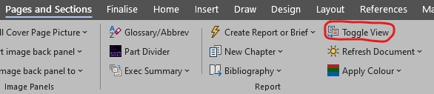
- If you’ve ‘hand build’ your document, delete this ‘starting point’ by placing your cursor anywhere on this page and selecting ‘Pages/Sections=>DELETE section’ in the ‘Other Section Options’ panel

